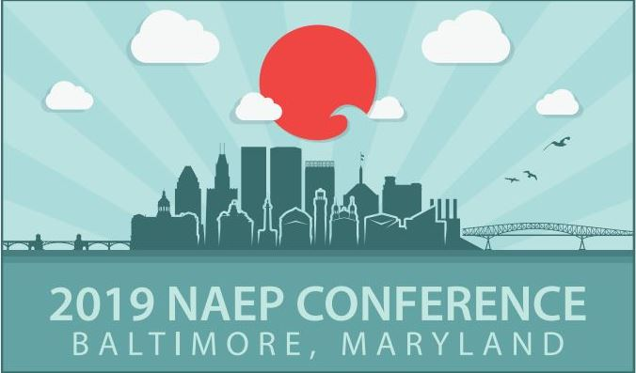
The Environmental Landscape in an Age of Infrastructure Modernization
MAY 19–23, 2019 • BALTIMORE, MARYLAND
CALL FOR ABSTRACTS
The excitement is brewing in Baltimore in anticipation for next year’s NAEP Conference. This is your opportunity to brag about your projects, let other environmental professionals learn about your techniques, network and partner, and partake in the unique Baltimore way of life. Submit your abstract early in order to get a choice spot on the program.
Abstracts may be submitted until the September 15th deadline by clicking here. The sooner, the better.
The abstract must have the following attributes:
• 300 words or less;
• In Microsoft Word, Times New Roman, 12 font;
• Include one or two keywords that describe the general category of the paper; and
• The final title(s) of the session(s) and paper(s). No changes will be allowed, so come up with a well thought out one. Also provide us with the name of the moderator/organizer or session chair and their contact information. It is not necessary to include the names of all authors or presenters at this time.
Contact Gary Kelman at garyfkelman@gmail.com for any abstract submittal questions or if you want to volunteer to lead a track or session.
Abstracts will be accepted for oral presentations, posters, workshops, and special sessions focused toward the following suggested topics. Other topics may be suggested. Be creative.

• Air Quality
• Agriculture Issues
• Chesapeake Bay
• Climate Change
• Cultural and Historic Resources
• Ecological Restoration

• Endangered Species
• Energy
• Role of Government in Environmental Improvement
• Infrastructure Upgrades and the Environment

• Interstate Partnerships
• National Environmental Policy Act
• Planning and Permitting
• Public Involvement

• Remediation, Brownfields, and Emerging Contaminant Issues
• Stormwater
• Transportation
• Water Resources

